**How to install Keil µVision4**

The Evaluation version of Keil for ARM is available for download at [http://www.keil.com/demo/](http://www.keil.com/demo/" \t ")  
  
Once downloaded, follow further steps:

1. Run setup file MDK-ARM V4.13a.exe (Double click the file icon)  
  
2. Setup Window appears....

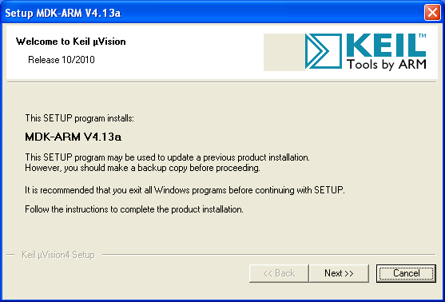

3. Click Next.

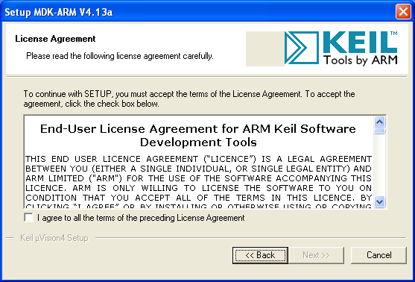

4. Click Checkbox of agreement in order to proceed and click Next.

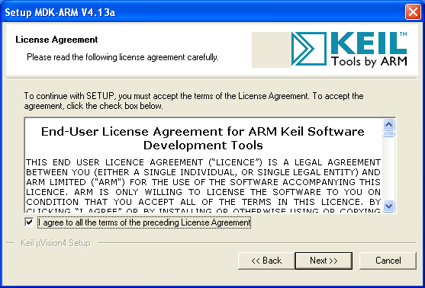

5. In folder selection window, select suitable directory for the installation and press next. (default directory should work fine!)

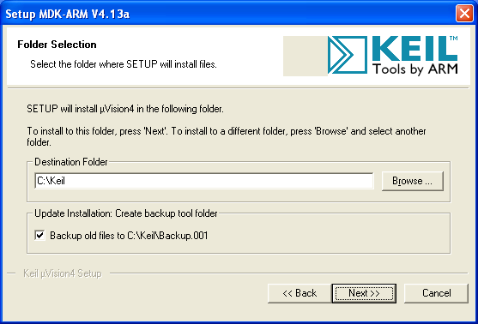

6. Enter customer information and click next.

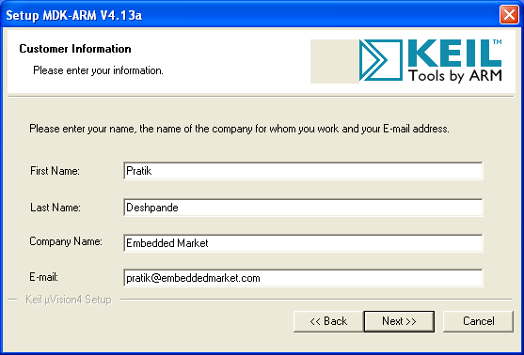

7. The setup should begin. Setup status window will show installation of different files. Wait until it gets installed completely.

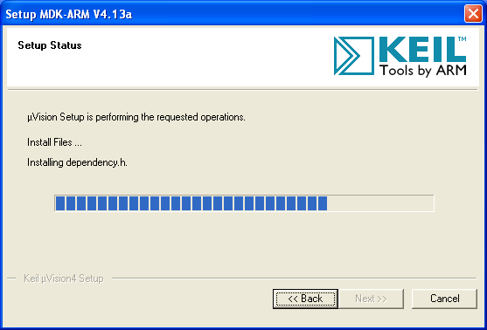

8. Once the installation gets over, message should appear with text �File installation completed�. Click Next without making any changes anywhere in the window.

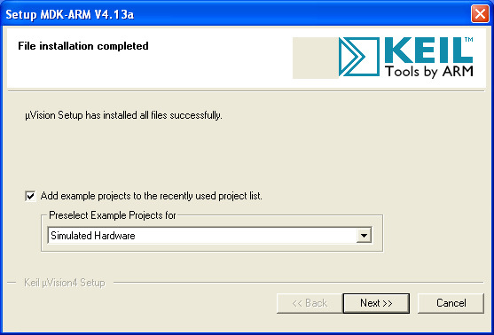

9. Next message will confirm �Keil uVision 4 Setup completed�. Click Finish

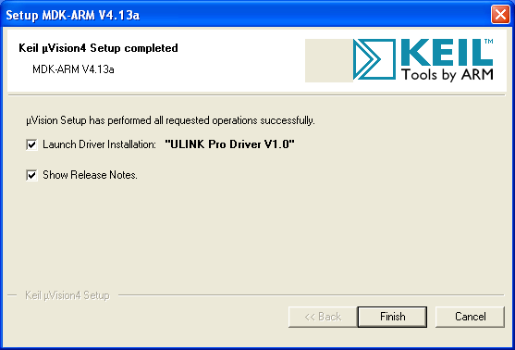

10. This will lead you to the webpage of Keil Development Suit for ARM. This will provide you release notes for Keil Development kit. This document gives you the brief idea of which microcontrollers are being added in the Keil uVision 4.

11. Run �Keil uVision 4� by double clicking the "Keil uVision 4" icon from the desktop. Same can be done from Start menu.

12. The work environment of Keil ready to use.

